[Jakob Nielsen's 10 usability heuristics:]
- visibility of system status: communicate the status of system through appropriate feedback within reasonable time.
  - For screen loading errors, image loading errors, failure to log in, password incorrect, etc., needs to be message indicating the error occurring. User needs to understand what is going wrong.
- match between system and real world: no jargon, familiar verbiage, following real-world conventions for upmost accessibility.
  - Appealing to 3 to 12-year-olds, requiring fun, safe, and easy language, including ‘about us’ description and product descriptions.
- user control and freedom: users can make mistakes so they will require an 'emergency exit'. make it easy to exit/undo action.
  - Return buttons to go back to previous page, easy access to delete product from basket, change details on profile.
  - header must be present on every page including basket for easy travelling.
- consistency and standards: follow platform and industry conventions. don't force user to learn something new.
  - https://www.justgeek.com/
    - Similar product and audience
    - Layout is consistent, brand colours and logo are apparent.
    - Easy manoeuvrability.
- error prevention: slips (unconscious) - caused by inattention. mistakes (conscious) - mismatch between user's mental model and design.
- recognition over recall: make elements, actions, and options visible. users shouldn't have to remember information; it should be readily available across interface.
  - All pages must be accessible from every individual page (header on every page)
  - Pricing, description, and brand intention (e.g. target age group, product aim,) always available on every product.
  - Website about us must include information about intention and aim of the products.
- flexibility and efficiency of use: shortcuts allow both inexperienced and experienced users to interact freely, increasing the likelihood of positive user experience.
  - E.g. if product has multiple images and can scroll through them interactively, provide arrows alluding to the interaction.
  - Links on images, e.g. clicking logo for home page.
- aesthetic and minimalist design: no unnecessary information. only enough to support the primary goal.
  - In mind with target age group, keep descriptions brief, catchy, and accurate.
  - https://www.justgeek.com/
    - Most websites have a whit background, minimal and sleek, not overwhelming, and allows for focal points.
    - Colours should be consistent; too many is overwhelming and messy. 2-3 brand-associated colours appealing to 3- to 12-year-olds.
    - Logo and mascot as appealing to children will help define that target age group. E.g these images that were created :
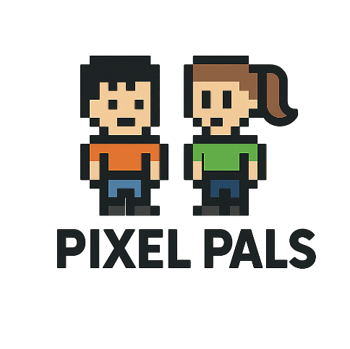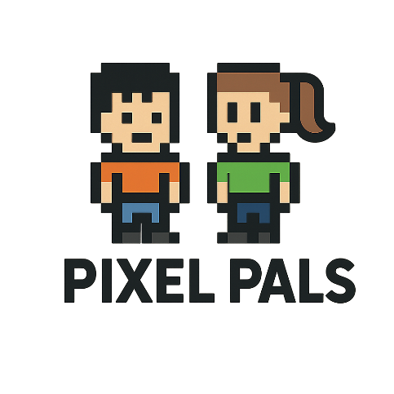
      - Those could help define the website colours, eg. Red, green, blue.
- recognise, diagnose, recover errors: error messages should be in plain language, not error codes. precisely communicate the issue and suggest a solution.
10. help and documentation: best option is no additional explanation, however, if necessary, keep concise, concrete steps that need to be carried out to complete tasks.

